|  |  |
| --- | --- |
|  |  |

|  |
| --- |
| **Activity 6.2.2 Switches, Diodes, and Light Emitting Diodes** |

Introduction

You have probably noticed that tail lights on cars and some traffic lights look like a collection of tiny light bulbs. Actually those small lights are Light Emitting Diodes (LED)s. Using LEDs allows these systems to use less power, stay cooler, and last longer than traditional light systems. As a direct result of LED lighting advantages, engineers are looking for more ways to implement this technology in everyday uses. In fact LEDs are a great way to light your home. Engineers are working hard to make that happen. Engineers face two challenges if they wish to increase our reliance on LEDs. LEDs do not do well in hot environments, and the light produced does not spread out as well as other lighting alternatives. Other uses include televisions for your home and the large screens at sporting venues. Since LEDs require so little energy, many of the activities in this course use them as indicators of electricity in circuits.

Equipment

* Switches, Diodes, Light Emitting Diodes presentation
* Computer with Internet
* Schematic Symbols Chart
* Engineering notebook
* Snap Circuits® components
* Board, voltage source, and power supply
* Motor
* Fan blade
* Various sizes of snap wires
* Slide switch
* Pushbutton switch
* Diode
* LED
* 6V / 0.5A light

Procedure

1. In teams of two, you will create circuits using switches, diodes, and LEDs. Complete the circuits and engineering journal entries as outlined in the Switches, Diodes, and Light Emitting Diodes presentation.
2. Complete the Schematic Symbols Chart as you learn about different electronic components and functions.

List and describe the four types of mechanical switches.

1. Pushbutton- A mechanical device used to connect or disconnect a component or circuit by pressing a button which connects 2 wires.
2. Slide- A mechanical device used to connect or disconnect a component or circuit by sliding a conductor which completes a circuit.
3. Rocker- A mechanical device used to connect or disconnect a component or circuit by flipping a button, allowing electrons to flow.
4. Toggle- A mechanical device used to connect or disconnect a component or circuit by flipping a switch that allows electrons to flow.

In the space to the right, draw a schematic for a circuit that will power a lamp using a slide switch and a DC source.

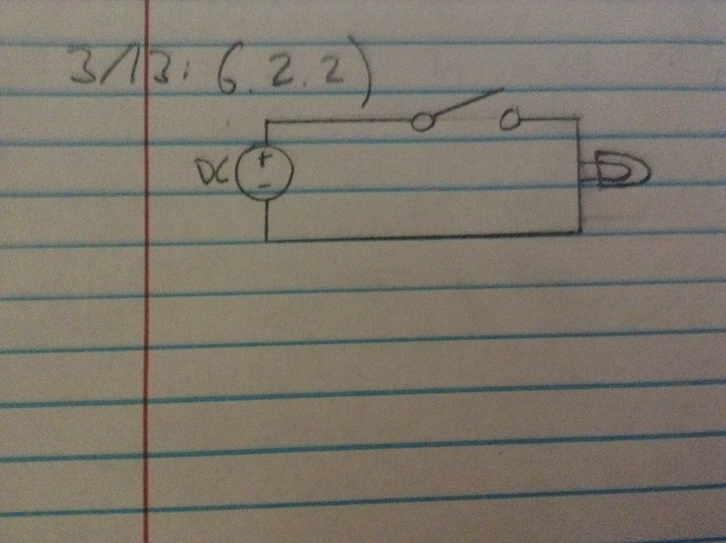

In the space to the right, draw a schematic for a circuit that will power a motor using a pushbutton switch and a DC source.

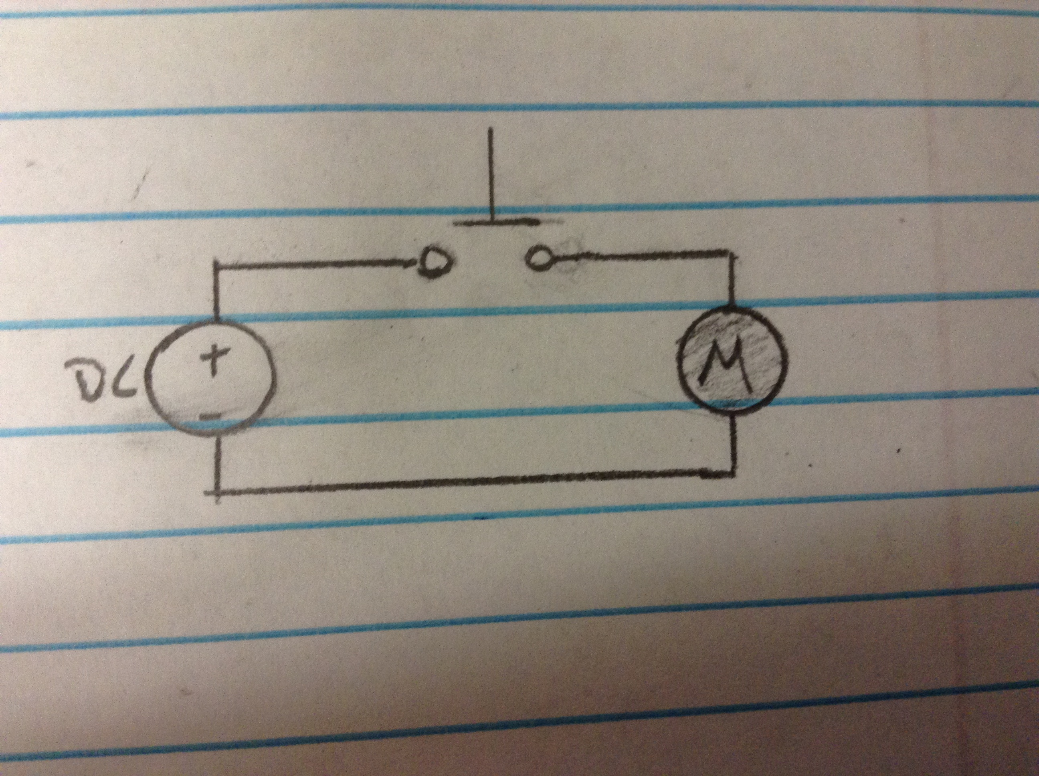

What is the purpose of a diode?

To only allow electrons to flow in one direction.

As we learned previously, both p-type and n-type doping of silicon conduct electricity. They just differ in HOWthey conduct. However, when p-type silicon is formed in a chip with n-type silicon, electrons will flow through the silicon IN ONE DIRECTION.

This is called the “THE PRINCIPLE OF THE DIODE”.

Where these two types of silicon intersect is called THE PN JUNCTION.**How the Diode works** - A diode is like a ONE-WAY VALVE for electricity. Current can only flow through it in one direction. Here’s a simplified explanation of how a diode conducts electricity in one direction (FORWARD) while blocking the flow of current in the opposite direction (REVERSE).

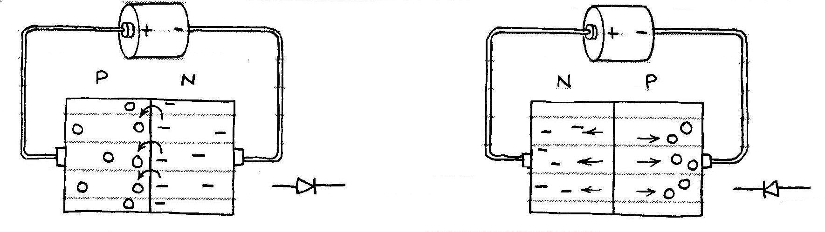

Electron Flow

No Current Flow

Hole flow

Here the charge from the battery ATTRACTS holes towards the negative, and electrons towards the positive, both AWAY from the junction. Therefore, no current can flow

Here the charge from the battery REPELS the electrons and holes towards the PN junction. If there is enough voltage, the electrons will CROSS the junction and current will flow.

Here the charge from the battery

*_________* the electrons and holes

towards the PN junction. If there is

enough voltage, the electrons will

*__________* the junction and

current will flow.

Here the charge from the battery

*_____________*holes towards the

negative, and electrons towards the

positive, both *____________* from

the junction. Therefore, no current

can flow.

Diodes are commonly enclosed in a small glass cylinder. A dark band marks the NEGATIVE terminal. The opposite terminal is the POSITIVE.

There are many different types of diodes, which are used in many different applications. One type the RECTIFIER is used to convert AC power to DC power.

In the space to the right, draw a schematic for a circuit that uses a DC source to power a lamp and includes a diode.

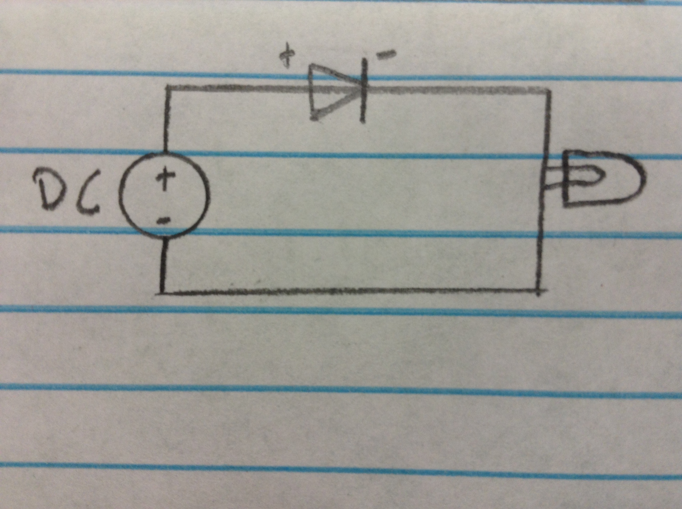

An **LED** is a special kind of diode that lights and is used in a circuit to show that a current is flowing. LED stands for LIGHT EMITTING DIODE.

 An LED sometimes has one leg SHORTER than the other. The shorter leg is NEGATIVE and the longer one is POSITIVE. The negative leg might also have a FLAT SIDE on the plastic cap to help you identify it. It is important to connect the LED’s legs the right way in a circuit (negative to negative, positive to positive).

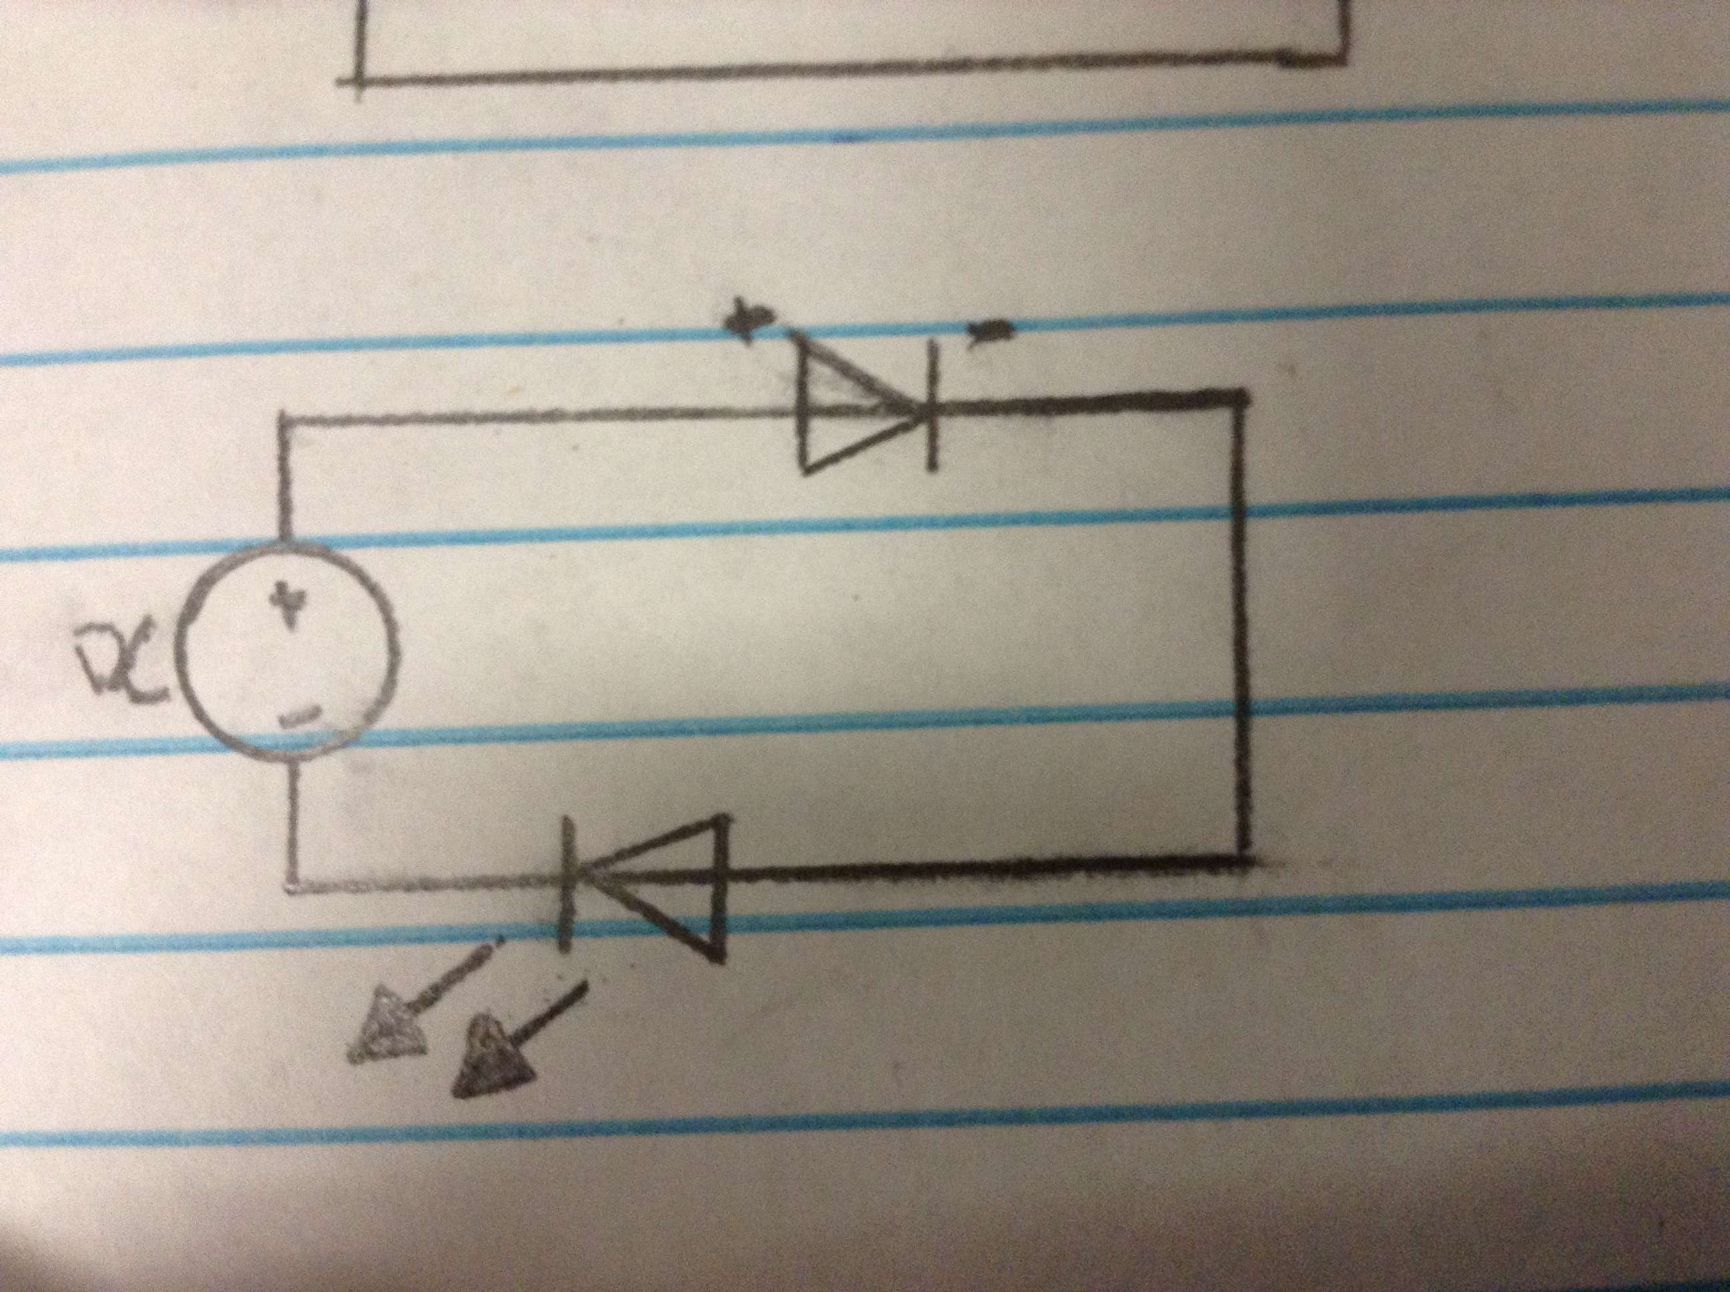

In the space to the right, draw a schematic for a circuit that uses a DC source that will power and LED and includes a diode.

Describe or draw a diagram that shows the Conventional Current Flow Theory.

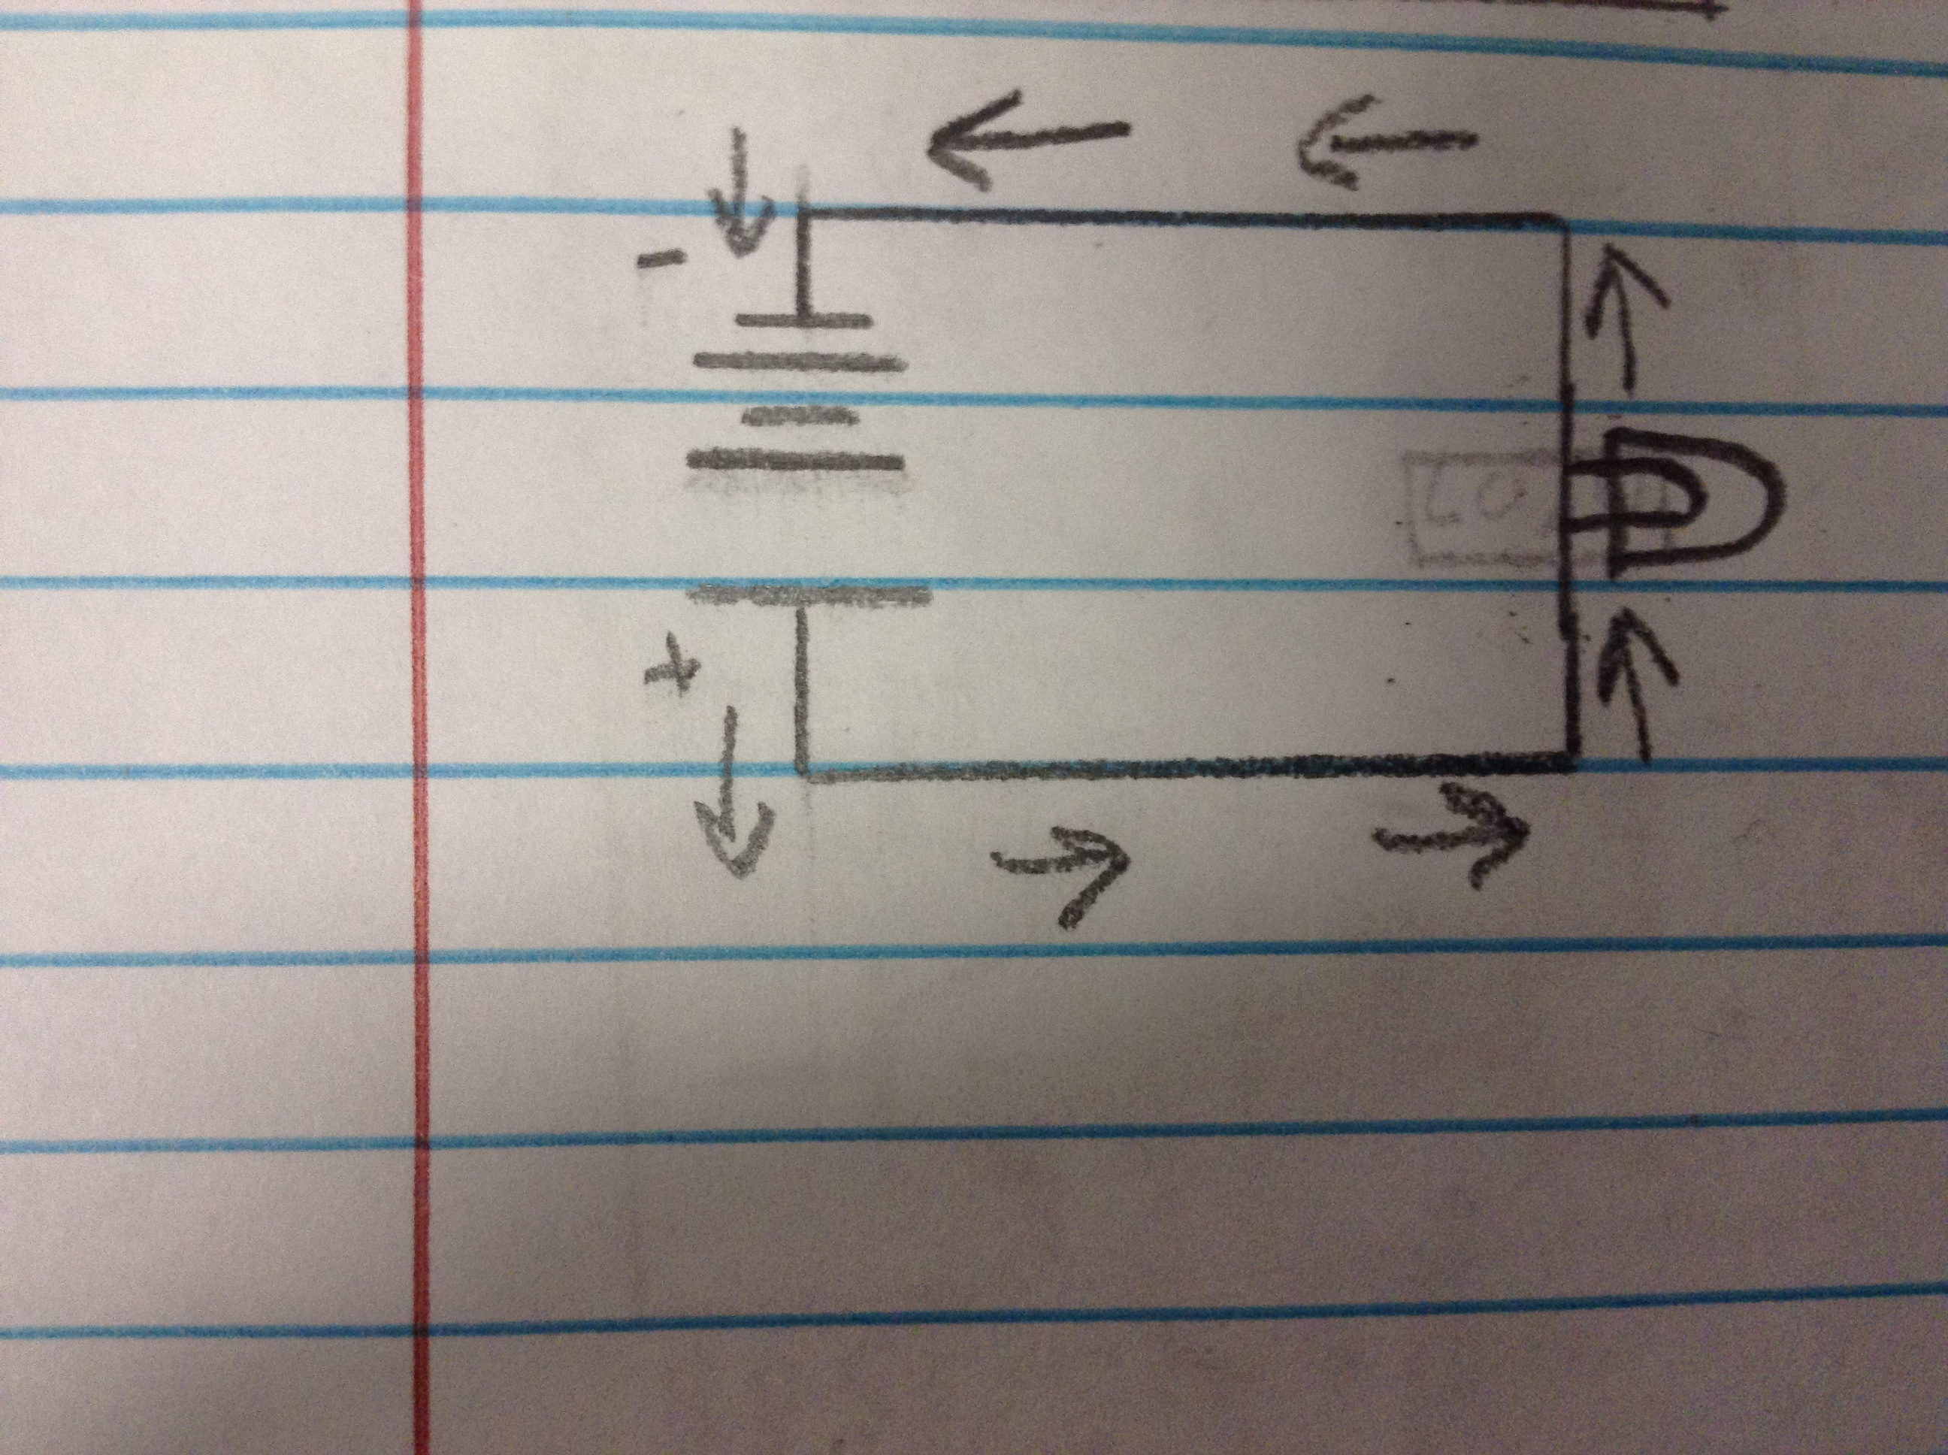

Describe or draw a diagram that shows the Electron Flow Theory. Using the schematics you drew of the pictures in the presentation, build the following circuits. Be sure to have your instructor sign your paper for confirmation.

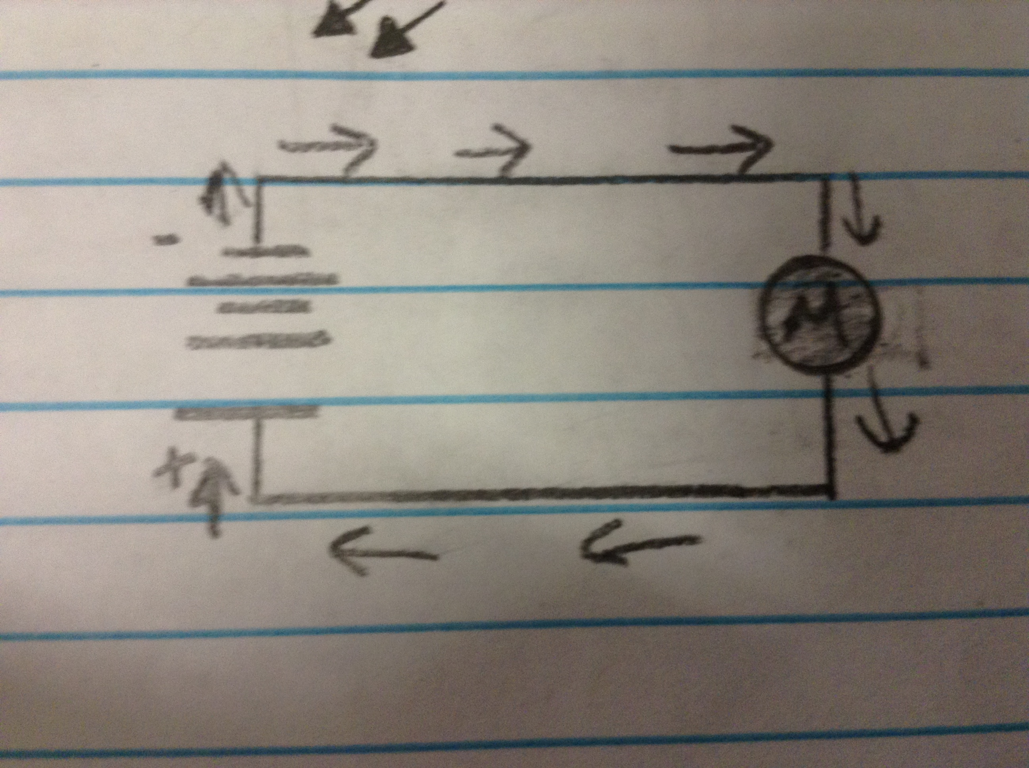

Lamp with slide switch:

Circuit Construction ______________

Motor with push button switch:

Circuit Construction ______________

Observations:

1. Turn the motor around in the circuit. What happens?

The motor spins in the opposite direction.

1. Does the motor have polarity (meaning, it HAS to be connected in the circuit in a specific way)?

No

Diode with lamp circuit:

Circuit Construction ______________

Observations:

1. Did the lamp turn on with the first try?

No

1. Turn the diode around. What happens?

The lamp turned on.

1. Why?

Because a diode only allows electricity to flow in one direction and if it is backwards electricity can’t flow.

Diode with LED circuit:

Circuit Construction ______________

Observations:

1. Did the LED turn on with the first try?

Yes

1. What happens if your turn the LED around in the circuit?

The LED turns off.

1. What happens if you turn the diode around in the circuit?

The LED turns off.

1. Explain what is happening in questions #2 and #3 above.

Since any diode only allows electricity to flow in one direction, electrons can’t flow when either diode is backwards.

1. In math, multiplying two negatives makes a positive. Explain what happens if you turn both the LED and the diode around in the circuit.

Electrons can only flow from one direction, and have to be facing the negative it only takes one backwards LED to break a circuit.

Conclusion

1. Diodes can be used to protect electronic components from current flowing in another direction. Describe another application outside of electronics where it would be important for something to flow in only one direction.

Water in drain pipes need to only flow in one direction because the drainage shouldn’t come back up.

1. Describe three objects in your house that utilize LEDs.

Lamps that use a LED bulb and shines when electrons flow through it.

Stovetop light uses LEDs to light up the stove when currents flows through the LEDs.

Refrigerator lights use LEDs to illuminate the inside of the fridge when an electrical current flows through it.

1. Use the Internet to research the use of LED systems to replace general household lighting. Describe one advantage and one disadvantage of replacing standard light bulbs with LED lighting.

LED lighting uses less power than standard bulbs, making it “greener”, but cost more making people lean towards the standard bulbs because they do the same job for less.

1. What are the two ways to determine the negative leg of an LED?

The negative leg can be shorter or has a flat edge on the outer casing.